**TUPLE:**

Tuple are used to store multiple items in a single variable.A tuple is a collection which is ordered,unchangeable and allow duplicate values.Tuple items are indexed,the first item has index [0],the second item has index[1],etc.Tuples are written with round brackets().

***Syntax:***

t=()

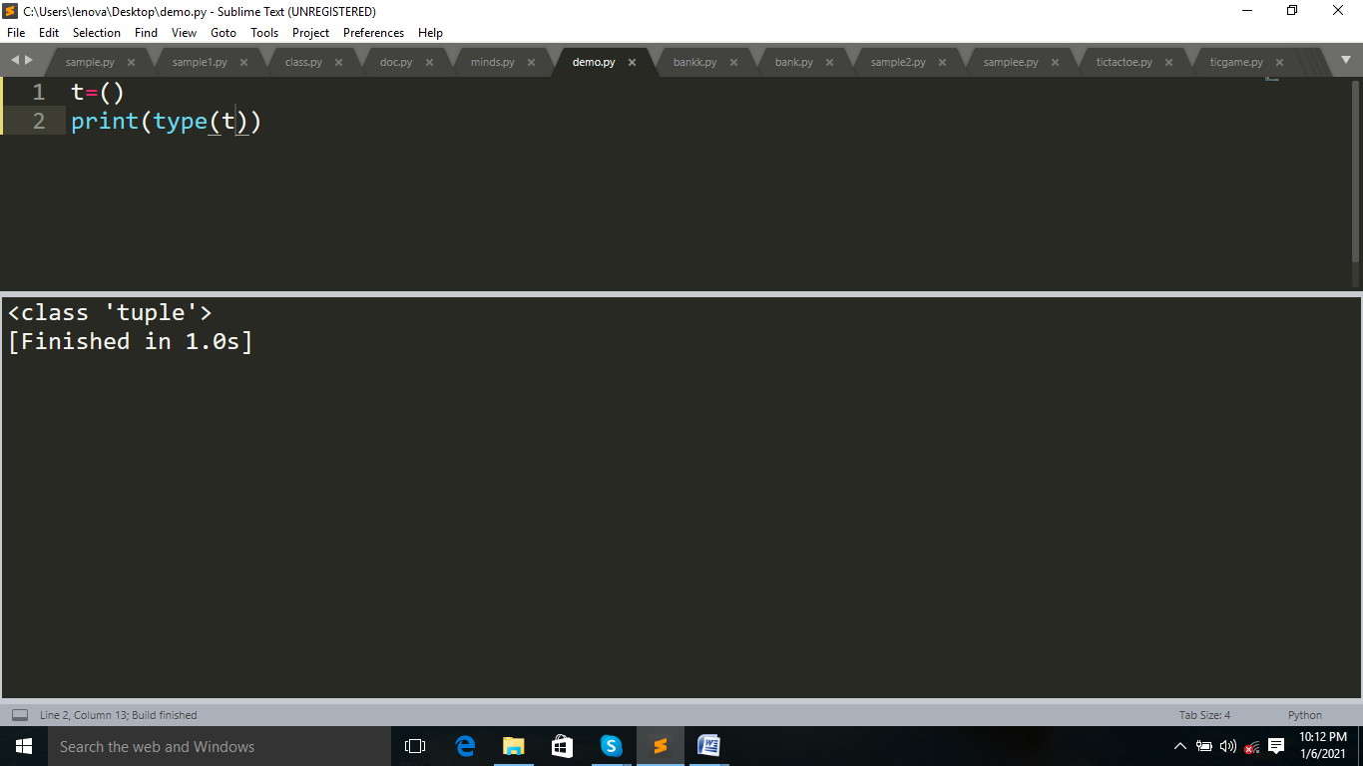

***Example:***

t=("apple",1,1.0,[1,2])#tuples allow diffeternt data types

print(t)

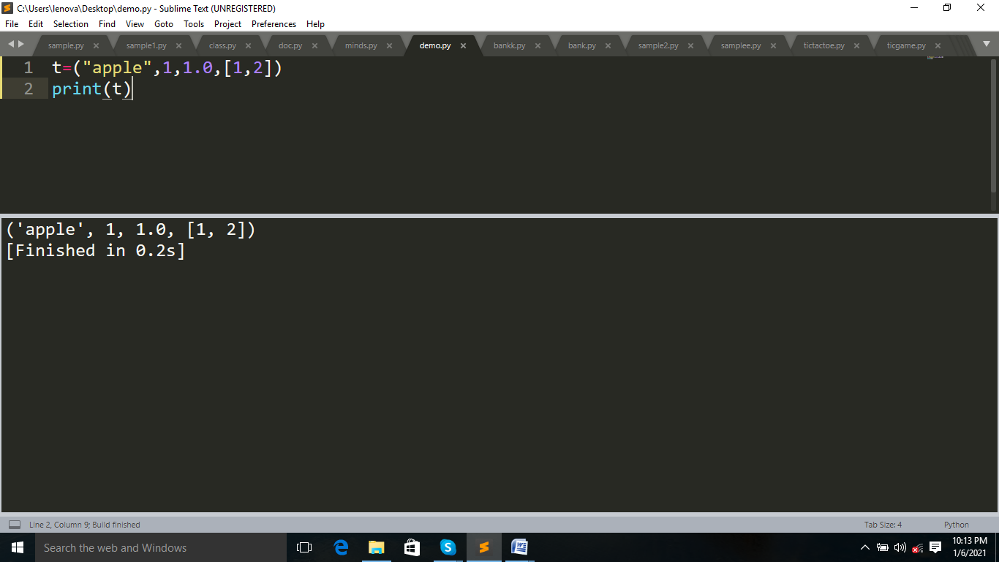

🡺To create tuple with one item,add comma after the item,otherwise python will not recognize it as a tuple.

***Example:***

t=("apple",)

print(t)

print(type(t))

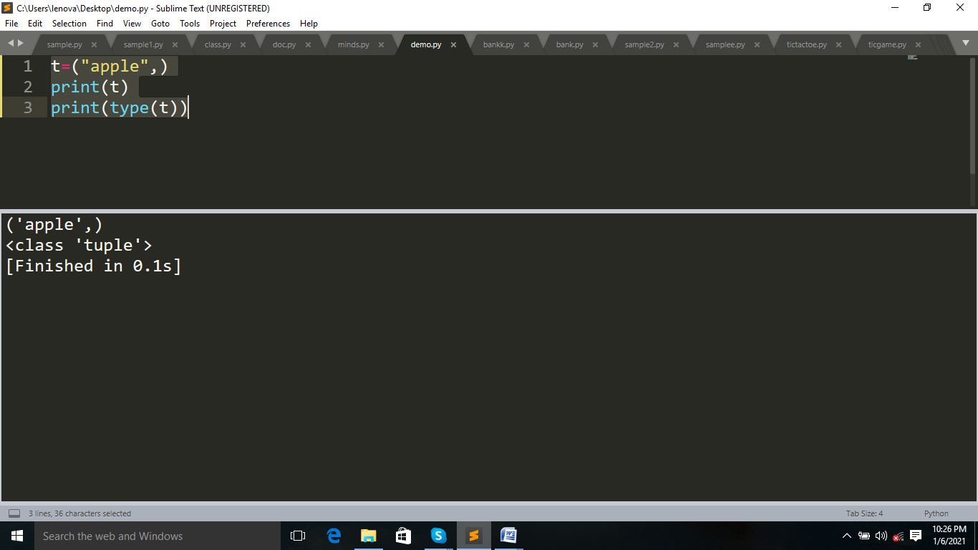

t=("apple")

print(t)

print(type(t))

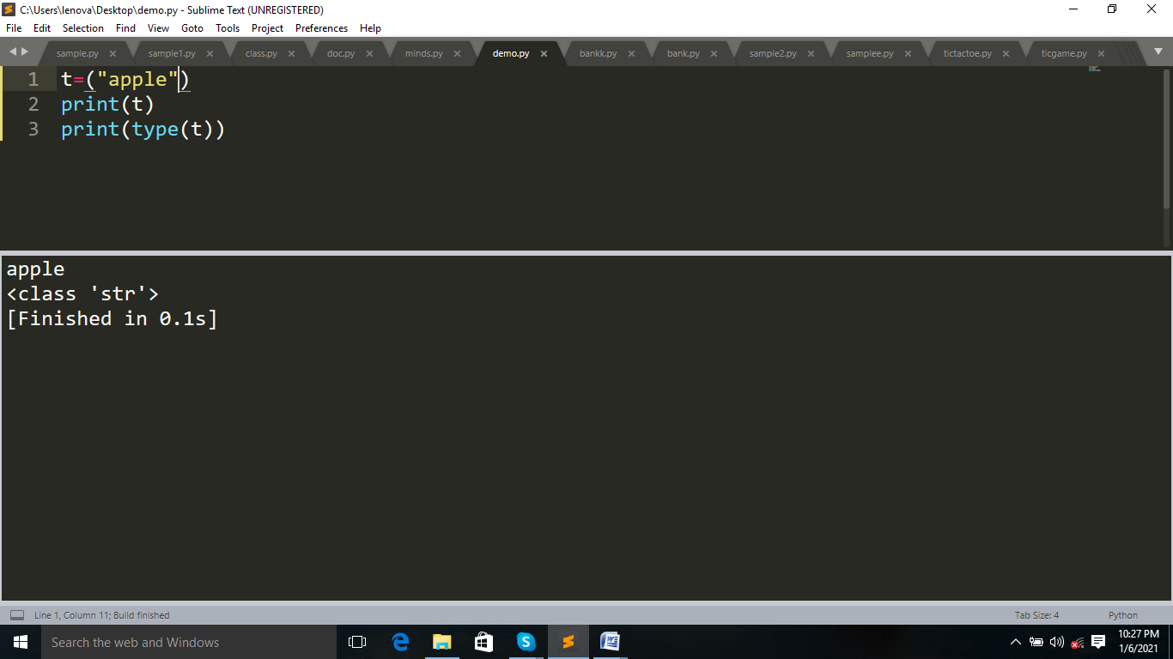

***Example:***

t=("apple",1,1.0,"apple")#order and allow duplicates

print(t)

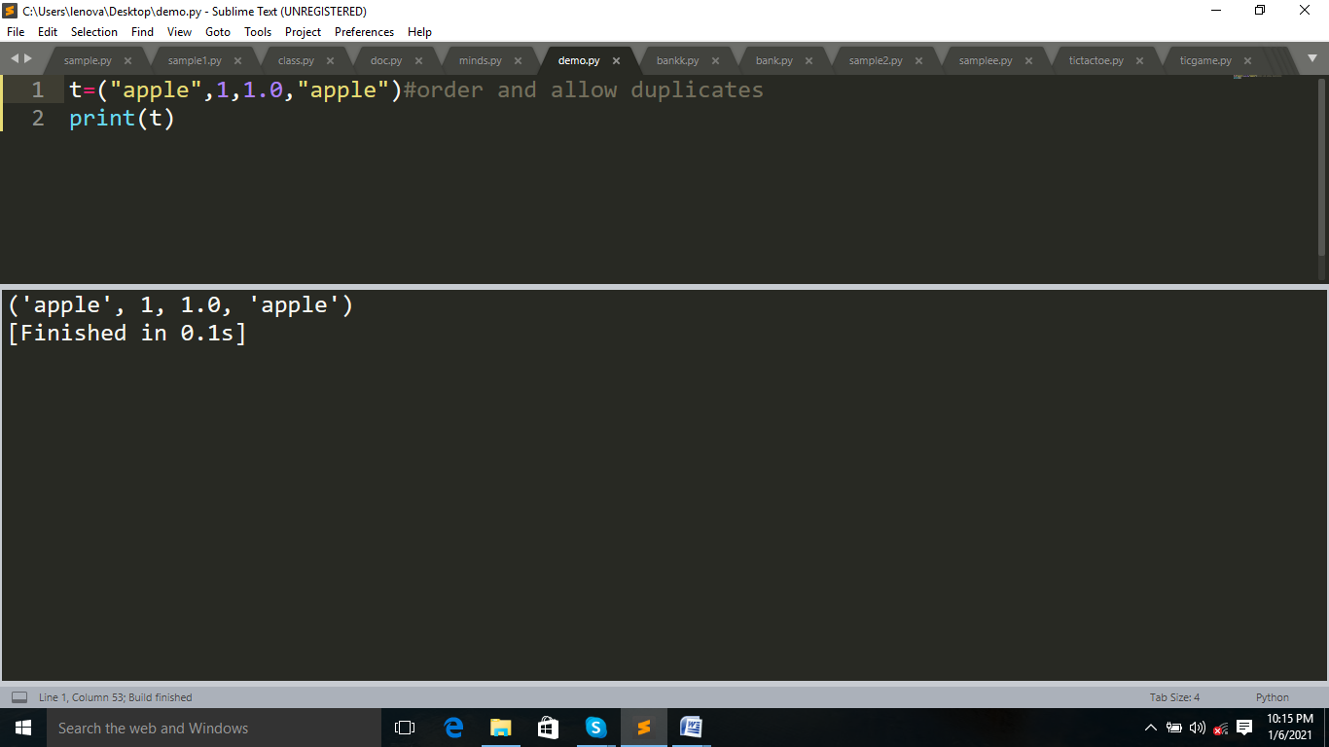

***Example:***

t=("apple",1,1.0,"apple")

t[0]="a"

print(t)

#tuple is unchangeable,we cannot add or remove items in tuple.

#if we change ,its through error

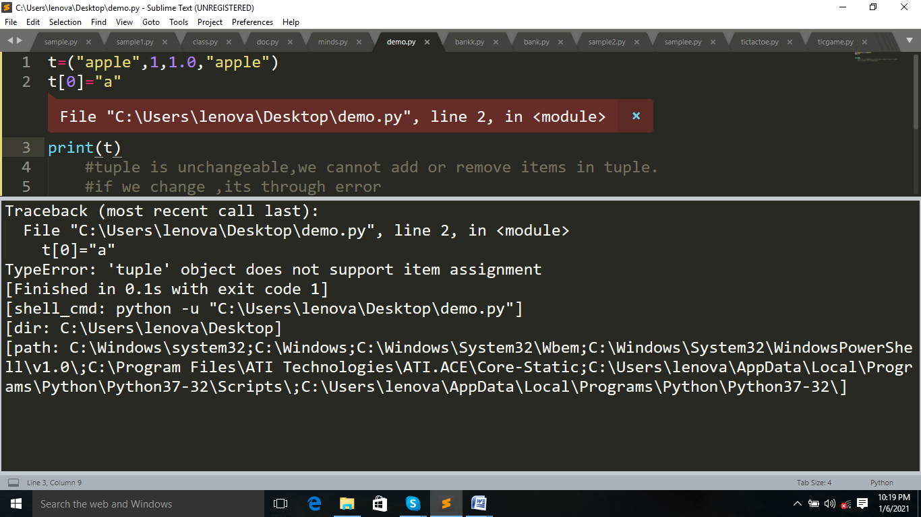

**To find the length of Tuple:**

Use len() function.

***Example:***

t=("apple",1,1.0,"apple")

print(len(t))

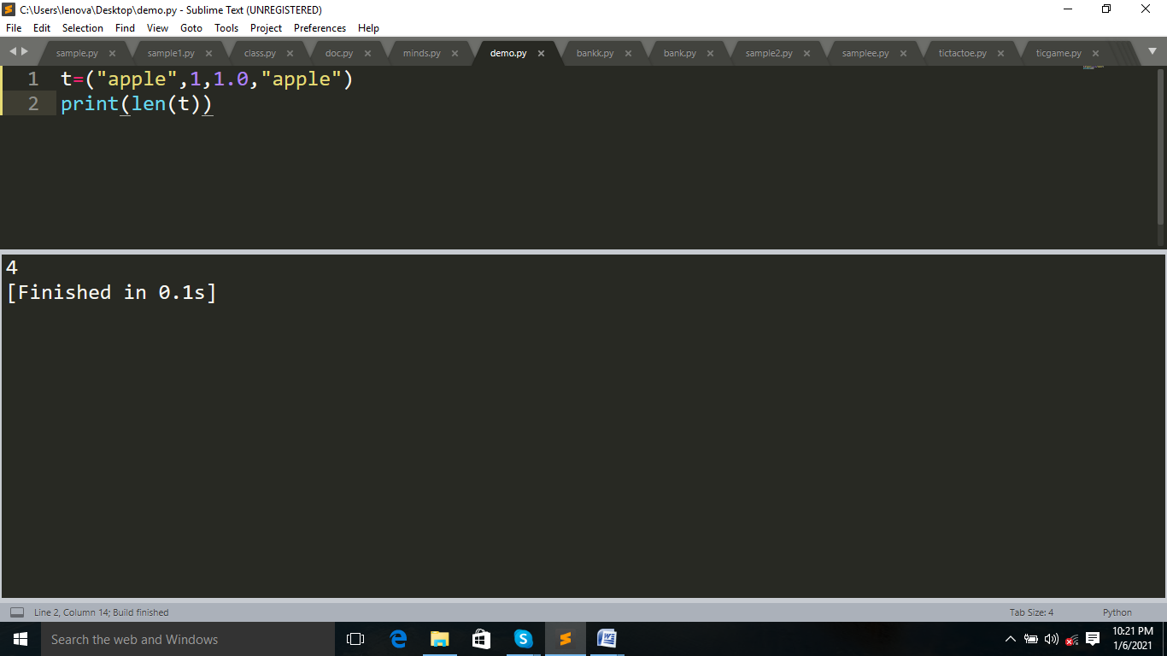

**It has two methods:**

**1.Index:**To access the item,by referring to the index number.

Negative indexing start from the end,-1 refer to the last item,and -2 refer to the second last item etc.

***Example:***

t=(1,2)

print(t[1])#positive indexing

print(t[-1])#negative indexing

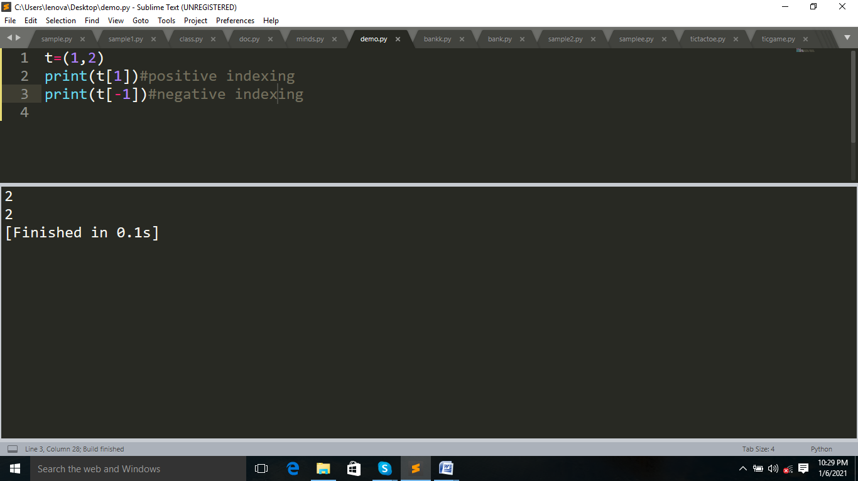

**2.Count:**

The count() method returs the number of elements with the specified value.

***Example:***

t=(1,2,"apple",1)

print(t.count(1))

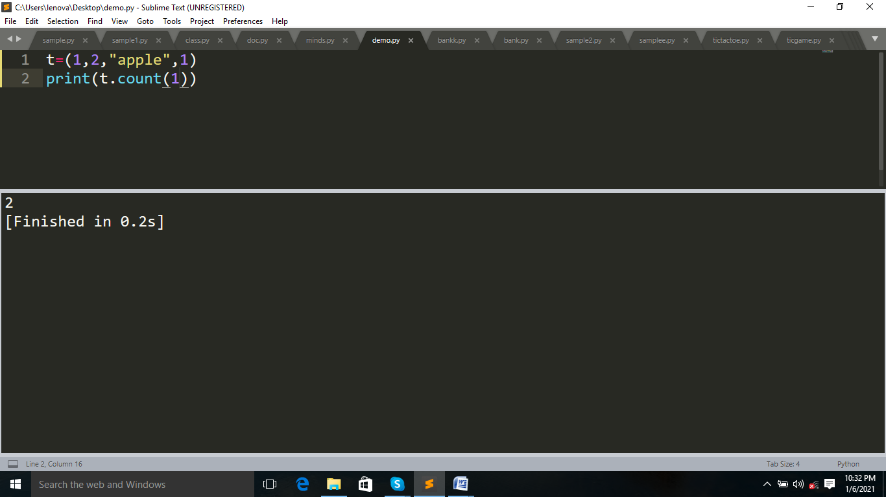

**Adding a value to the tupple**:

***Example:***

t=(1,2,"apple",1)

print(t)

t=t+(1,)

print(t)

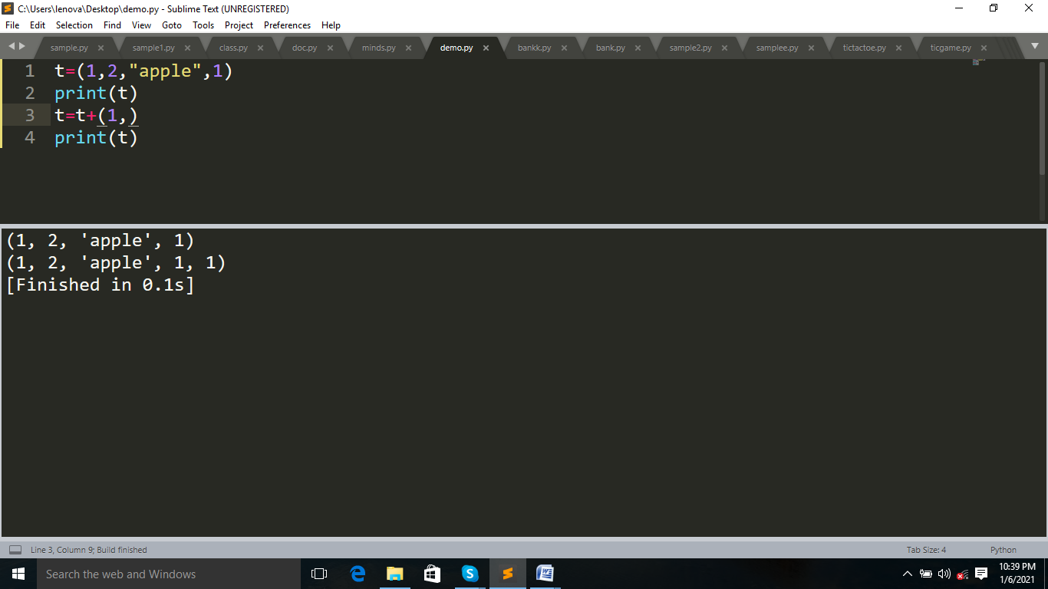

***Example:***

t=(1,2,"apple",1)

print(id(t))

print(t)

t=t+(1,)

print(id(t))

print(t)

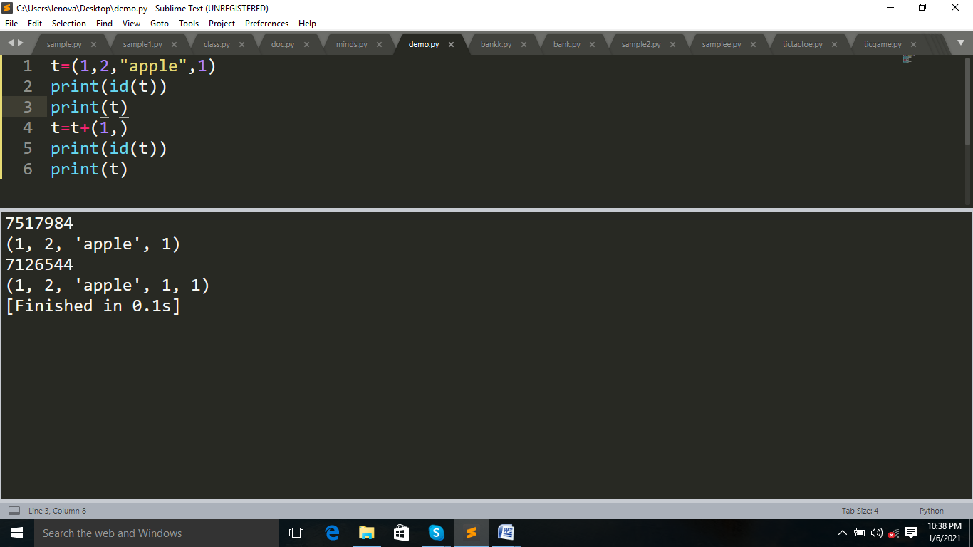

**How to change values in tuple:**

Change the tuple to list,then add or remove or sort the values.

***Example:***

t=(1,2,"apple",1)

l=list(t)#convert tuple to list

print(l)

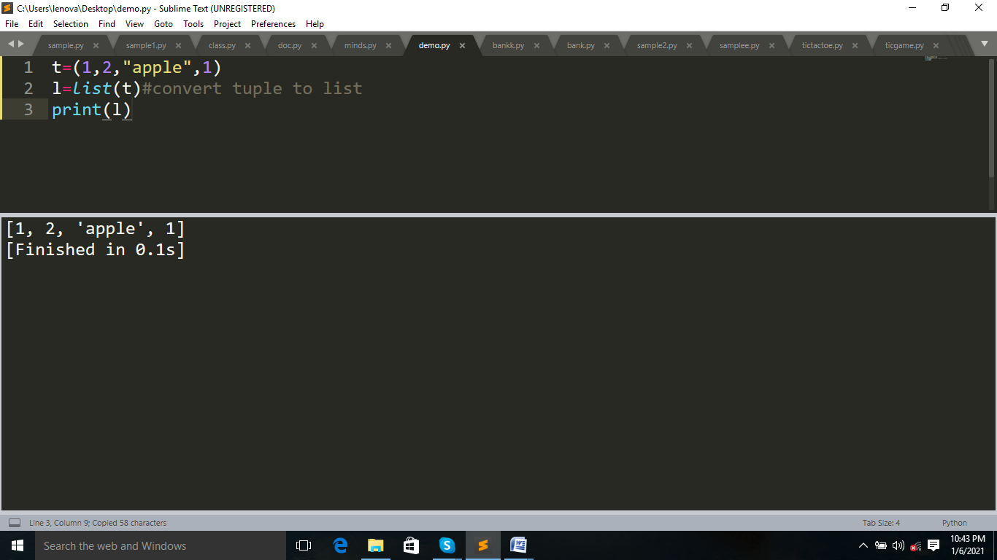

***Example:***

t=(1,2,"apple",1)

l=list(t)#convert tuple to list

l.append("a")

print(tuple(l))#then converted into tuple

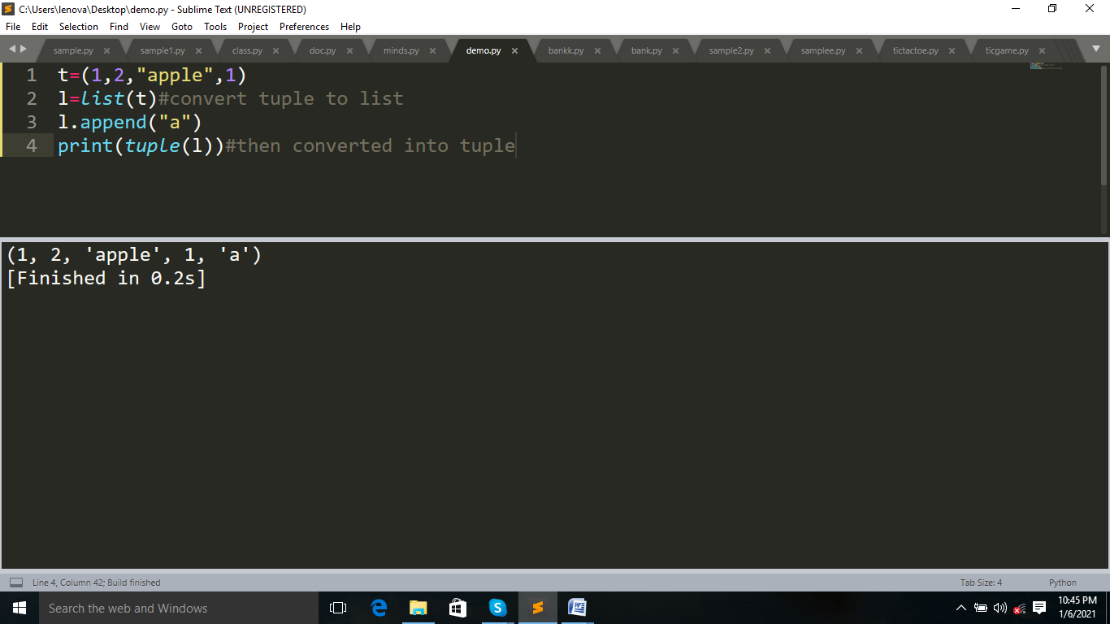

**SLICING:**

Return a range of character by using slicing syntax.It specify the start index and end index,separated by a colon,to return a part of string.

***Syntax:***

S[start:end:jump]

***Example:***

t=(1,2,"apple",1)

print(t[0:])#start index

print(t[:5])#end index

print(t[1:4])#jump=default(1)

print(t[1:4:2])#here jump=2

#negative indexing

print(t[-3:-1])

